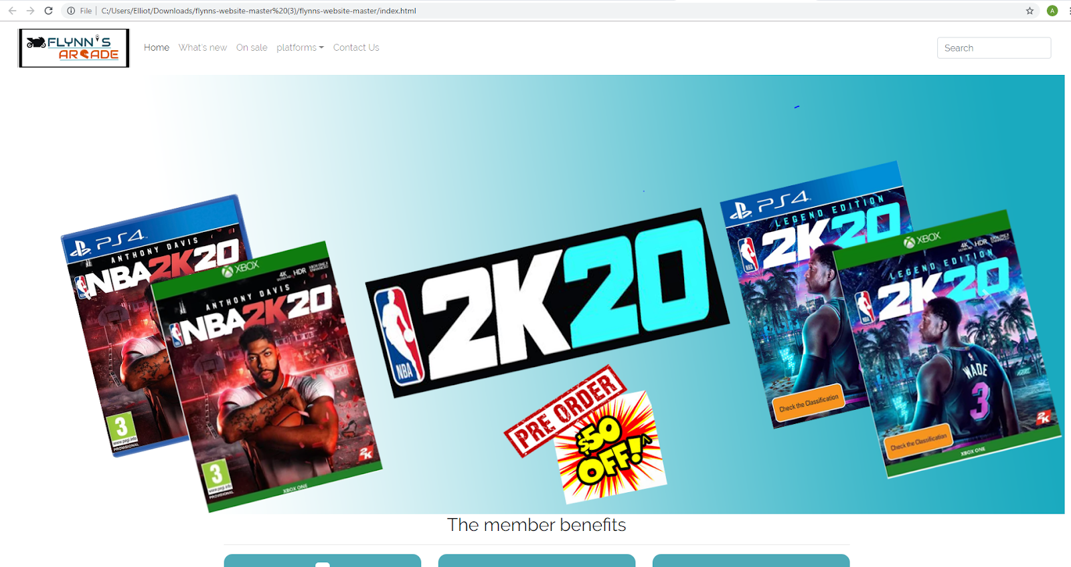

Flynn’s Website

Portfolio

Rod Vincent Marabella | 19/9/2019 | IST

Table of Contents

Design brief 2

Area of Investigation/Research 3

Comparison of website creation tools (IDE, CMS, drag and drop tools) 6

Background research on Flynn and his aesthetic design 7

Design sketches 8

Final concept/Design 9

Design changes 10

Evaluation 11

Bibliography 12

## Design brief

Flynn’s Arcade has been slowly using money as the trend for accessing video games has moved away from social ‘video game arcades’ to at home ‘video game consoles’ such as Atari & Commodore 64. Flynn wants to reposition his business as a venue for selling new games and trading used games. Flynn wants you to design and create ‘alpha phase’ website that communicates his new business model.

Criteria for success:

* Contact information should be clearly provided
* It must have a products to sell/buy
* The website should be simple but unique
* The links that the sites provide should be reputable and reliable
* Objectivity of the sites should be clear
* Include well design and written headlines

## Area of Investigation/Research

We’ve been researching on how to design our website by looking at many websites like JB Hi-fi & Eb games to give us an idea on how we are going to construct and design our website for Flynn to be unique. It also helps me on how am I going to create and design my contact page and home page by getting some ideas on the given websites.

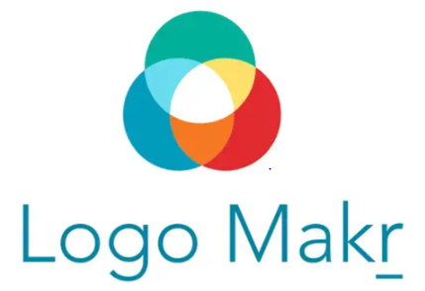Logomakr:

When I made my website, I used logomakr to make the logo. It was really helpful because it’s easier for me to design my logo and it uses variety of shapes, patterns and symbols to make my logo simple but unique.

Bootstrap :

We also used Bootsrap to help us create and design our website easier and faster. It also includes HTML and CSS based design templates that can be useful for our websites. It offers a lot of helper classes that make development of a website responsive easy and fast. Its very essential to use it because it provides all based design templates to make it easy for you to create and design your websites.

GitHub:

We used GitHub to save all our progress on creating and designing our website. It provides access control and collaboration to let you and others work together on projects from anywhere.

Photoshop:

We used Photoshop to edit our sliders for our website to show what we are selling or what’s new in our product. It’s really useful for me because it provides a wide range of tools to make easy for editing and designing my sliders.



Notepad++:

This is really useful for someone that work as a programmer or a web designer because it is a text editor and source code editor which supports all almost languages and it saves the file with a text extension. It also supports tabbed editing, which allows working with multiple open files in a single window.

 Wix:

Wix is a cloud-based web development platform which allows the users to create HTML5 websites and mobile sites through the use of online drag and drop tools. It can be used for blogging, hosting an online forum, building an online store to sell digital and physical products, appointment booking and collecting contact details. It’s very essential to use Wix because it helps you a lot by making your website by using variety of drag and drop tools

Duda:

It is a web design platform for media agencies and companies that offer web design service. It provides users with a website builder, team collaboration and client management tools to manage its service. Duda offers a variety of products and features for web professionals and solutions providers that need to create websites for their clients.



Weebly:

Weebly is website building program. The online platform strips away the need for manual coding and replaces the process with an intuitive drag and drop interface. It provides hosting for all the websites that are built on their platform. You can easily make a website and it automatically generate into a mobile version of what you made.

 WordPress:

It is an online and open source website creation tool based on PHP and MySQL. It is the most powerful blogging and website content management system in existence today.it is basically a software that manages content people put on their websites.

### Comparison of website creation tools (IDE, CMS, drag and drop tools)

IDE (integrated development environment) is a software applications that provides comprehensive facilities to computer programmers for software development. Tools that are provided by an IDE include text editor, a project editor and a tool bar. IDEs can perform a variety of functions like writing code, compile code and debug code.

The difference between IDE and CMS is that CMS (content management system) is a software too but with a different functions of web content management and enterprise content management. It only allows you to control and manage the content within your website. It’s very essential to use because without technical training, you can very easily add, delete images, and edit text in your website.

Drag and drop is basically a pointing device gesture that is used to describe then action of selecting an object or section of text, moving it (dragging), and then placing it (dropping) into an alternative area.

### Background research on Flynn and his aesthetic design

Sam Flynn was born in 1983, and He was a famous video creator and ENCOM CEO Kevin Flynn and architect Jordan Canas. In 2 years later Jordan Canas was killed in a car accident Sam’s father was on the verge of a major discovery when he disappeared without a trace. Sam was only six when his father disappeared. Sam was the largest shareholder of ENCOM. He also broke into the ENCOM tower and hacked the company’s mainframe.

Flynn’s aesthetic design would be the main background color of the movie and theme color of it of it which is basically some bright and dark colors that is significant to the movie. On the movie it shows a lot of design which based on the things that you see on the movie like the motorcycle, they made darker but with a brighter line color which make them more visible.

### Data communication and its implication for the web design

It refers to the exchange of data between a source and a receiver via form of transmission media such as a wire cable. It is the process of using computing and communications technologies to transfer data from one place to another and vice versa. It also transfer data over a point-to-point to multipoint communication channels

## Design sketches

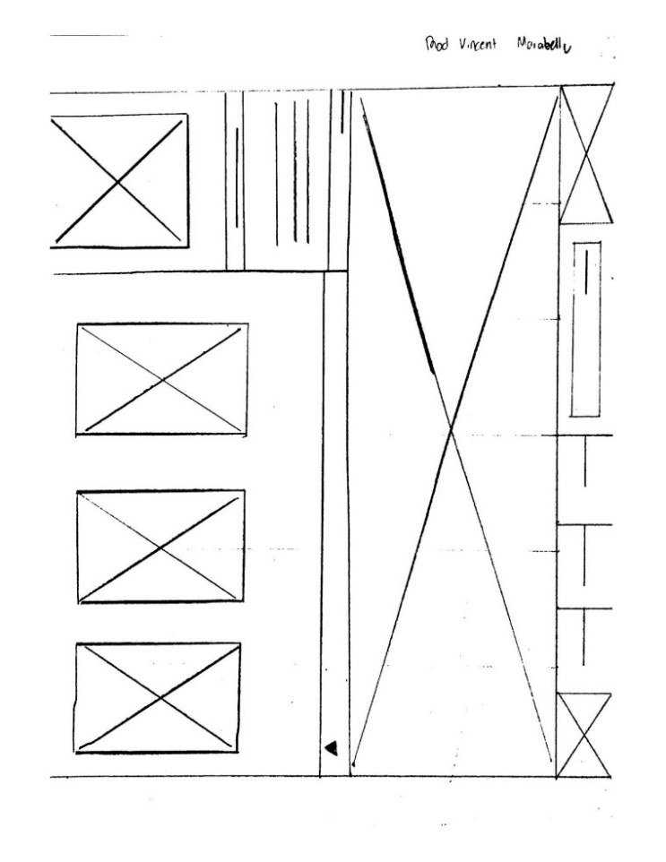

This is the sketches that I draw using wireframe ideas for Flynn’s websites. It really helps me to have an idea on how am I going to construct it and ideas for designing. The first thing that I did was looking at many websites by getting some idea like how big should your logo be , how many available features should be there and how to properly align it  and make size even so the people who were looking on it doesn't get confused about all of those stuff.

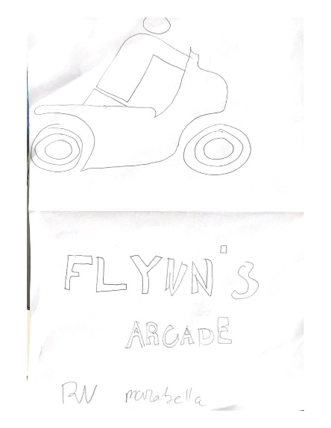This is what i draw for my logo on Flynn’s website. It gives me an idea of putting a motorcycle right next to it because on the movie it shows how they all used motorcycle for racing and at the same time in the battle. I also replaced the letter “C” on the word arcade and changing it to a helmet to be more unique and significant to the movie. It’s kind of easy to actually make the logo if you get an idea on the movie and actually basing it on what is the movie about.

## Final concept/Design

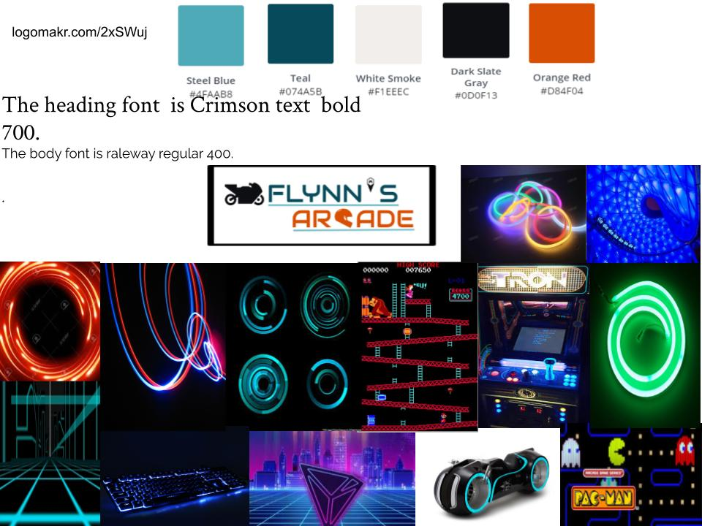

## Design changes

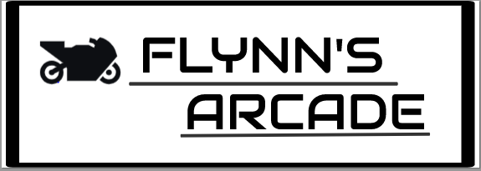

This is the first logo design that I made for Flynn’s websites. It is very simple actually because I just used a pixel fonts for actual logo name and I basically made it all black to be simple, but then I realized that it's very simple and people can easily remember but what i mean is it doesn't actually tell what is the logo’s about and how does it relate to the website or what is it about. So I decided to change and replace some words or icon to my original logo and make it more relatable and significant to the website.

Firstly, I replaced the apostrophe between the word Flynn and “s” and change it to a joystick which kind of looks like an arcade icon. Secondly, I replaced the letter “C’ on the word arcade and change it to a helmet which is exactly the same as the letter “C’. I chose this idea to help people understand what it is about and how does it help them and also it makes more relatable to the main purpose of the website and significant to it.

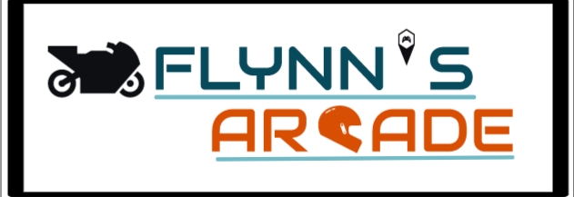 Lastly, I changed the colour of the name and the icon on the logo. I literally based it on the colour of the main background colour of the movie which is’ light blue, dark blue, white, and orange’ because I feel like it needs a brighter colour which can attract the people and can easily remember it. This is the final design for my logo to Flynn’s website

## Evaluation

When I was making my website I feel like I’ve done a good job about it. But sometimes I experience some errors on editing the website like the coding stuff it stressed me sometimes because whenever I’m trying to solve it, it just keep coming back with same problem, so I realized that I don’t have to edit it, I’m just missing something that that I forgot to write and it causing the errors. Sometimes I just have misspelled words too which causes errors.

I don’t have a problem constructing my website and placing them into the right place because by looking at many website like jb hi-fi and eb games it can actually give you an idea to properly design your website. I don’t have a problem on my contact page as well because all I need to do is put the contact information and the trading hours and make it more helpful to the people who is looking it.

In all of my design in my website was pretty alright and it’s kind of good actually even though it’s a bit simple but unique and I don’t have to stressed about on many things and it also help me to improve my coding skills and editing skills that may be helpful for me in the future.

## Bibliography

<https://en.wikipedia.org/wiki/Wix.com>

<https://en.wikipedia.org/wiki/Weebly>

<https://en.wikipedia.org/wiki/Duda_(software)>

<https://en.wikipedia.org/wiki/WordPress.com>

<https://en.wikipedia.org/wiki/Content_management_system>

<https://en.wikipedia.org/wiki/Integrated_development_environment>

<https://en.wikipedia.org/wiki/Drag_and_drop>

<https://tron.fandom.com/wiki/Flynn's_Arcade>

<https://logomakr.com/>

<https://getbootstrap.com/>

[https://github.com](https://github.com/)